Find the compressibility for carbon dioxide at 60 ˚C and 10 MPa using Diagram:
TR=60+272.15/304=1.09
PR=10*10/73.9=1.35
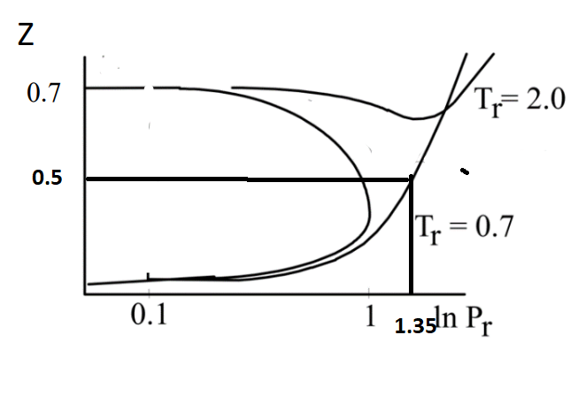
Z≅0.5
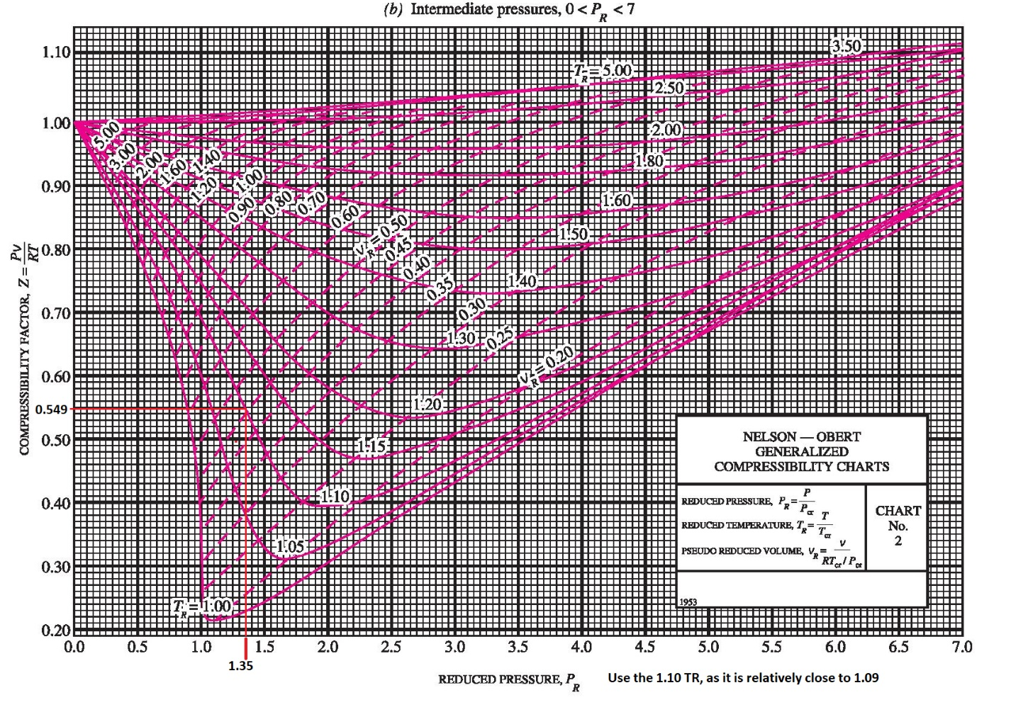
Z=1.549≅0.55

